**CHAPTER 1**

**INTRODUCTION**

**1.1 Project overview:**

We all know the importance of water, and I do not find any reason to repeat what everybody has said about the benefits of drinking water. (water equals life itself). We all certainly know that there is a drinking water crisis that appears in many countries to the extent that many Countries buying drinking water and transport it through water tankers, and the crisis will be worsen in the future

This dataset contains total 10 Columns, the first 9 columns are used as a input features,namely, PH value, Hardness, Solids, Chlorinates, Sulfate, Conductivity, Organic Carbon, Trihalomethanes ,Turbidity. In this dataset our main goal is to predict the water potability with values 1 (potable) and 0 (not potable).

**1.2 Purpose:**

Improve Water Accessibility: Enhance access to clean and portable water for communities, especially in underserved areas.

Ensure Water Quality: Monitor and maintain high-quality standards in water supply, ensuring it meets health and safety regulations.

Environmental Conservation: Analyze water-related data to understand its impact on the environment and devise eco-friendly strategies for water management.

Public Health Enhancement: Safeguard public health by identifying potential contaminants and preventing waterborne diseases through data-driven interventions.

Resource Optimization: Optimize the allocation of water resources by identifying patterns, reducing wastage, and improving distribution efficiency.

Data-Driven Policies: Provide policymakers with accurate insights to formulate evidence-based policies for sustainable water management.

Community Empowerment: Empower local communities with knowledge about their water sources, fostering a sense of ownership and encouraging responsible water usage.

Emergency Response: Establish a framework for early detection of water-related emergencies, enabling rapid response and mitigation efforts.

Education and Awareness: Raise awareness about water conservation and educate the public on responsible water usage through data-backed campaigns.

Long-Term Sustainability: Contribute to the long-term sustainability of water resources by fostering a culture of data-driven decision-making and continuous improvement in water management practices.

**CHAPTER 2**

**LITERATURE SURVEY**

**2.1 Existing problem:**

"Water Scarcity in Urban Areas due to Climate Change"

**2.2 References:**

Gleick, P. H. (1998). Water in Crisis: Paths to Sustainable Water Use. Daedalus, 227-244.This seminal paper discusses the global water crisis, highlighting the scarcity issues faced by urban areas.

IPCC. (2014). Climate Change 2014: Impacts, Adaptation, and Vulnerability. Contribution of Working Group II to the Fifth Assessment Report of the Intergovernmental Panel on Climate Change.This report provides comprehensive insights into the impacts of climate change, including its effects on water resources in urban regions.

Satterthwaite, D. (2011). The implications of population growth and urbanization for climate change. Environment and Urbanization, 21(2), 545-567.Satterthwaite's work explores the connections between population growth, urbanization, and climate change, shedding light on challenges faced by cities.

World Bank. (2016). High and Dry: Climate Change, Water, and the Economy. World Bank Group.This report analyzes the economic implications of water scarcity due to climate change, emphasizing the urgent need for adaptive strategies.

United Nations. (2018). The Sustainable Development Goals Report 2018. United Nations.This report provides an overview of global progress toward achieving the Sustainable Development Goals, including Goal 6 on clean water and sanitation, highlighting existing challenges.

**2.3 Problem Statement Definition**

"Inefficient Water Portability Assessment and Decision-Making"

Aquatic ecosystems are under constant threat due to pollution, climate change, and population growth. Ensuring the availability of portable water sources is crucial for public health and environmental sustainability. However, the existing methods for analyzing water portability data lack efficiency and fail to provide timely, accurate insights. Challenges include the integration of diverse data sources, real-time analysis, and intuitive visualization for effective decision-making.

**CHAPTER 3**

**IDEATION & PROPOSED SOLUTION**

**3.1 Empathy Map Canvas:**

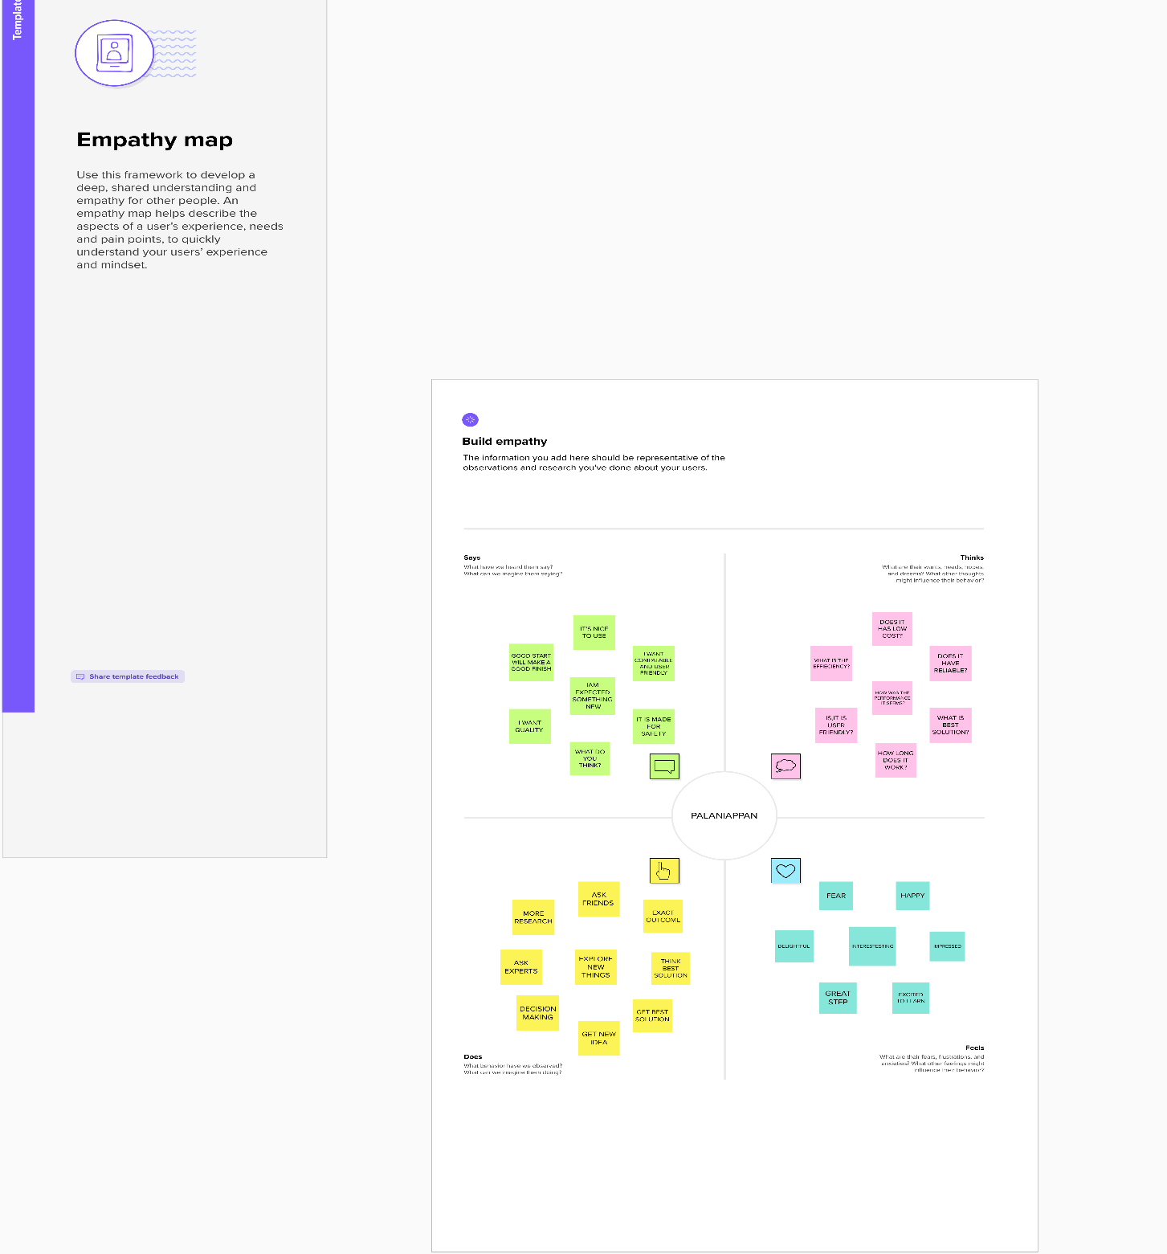

**3.2 Brainstorm & Idea Prioritization:**

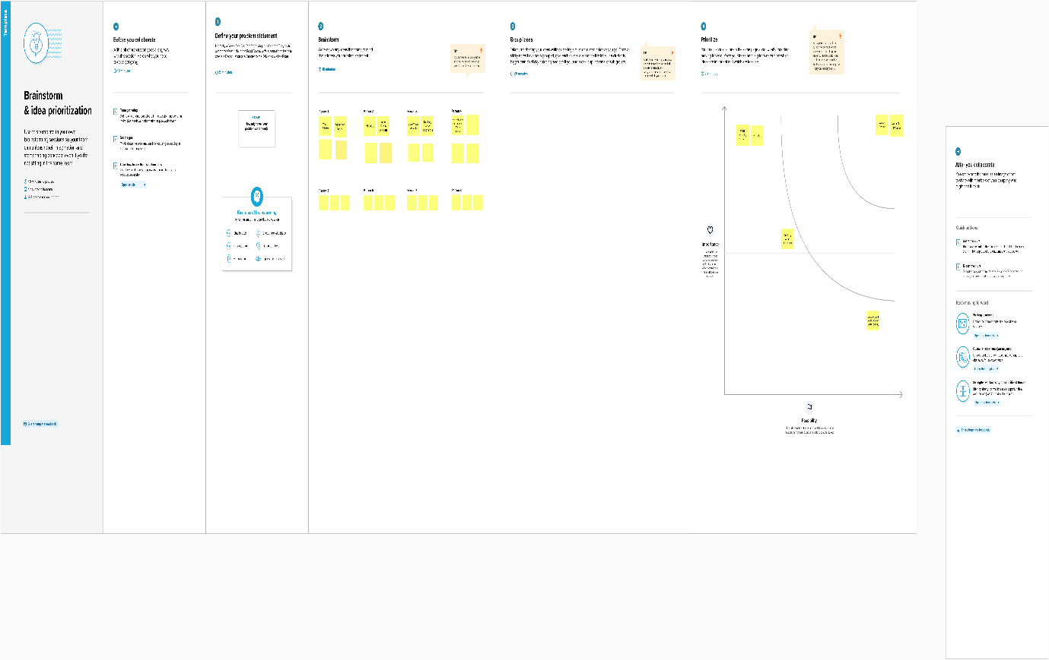

**CHAPTER 4**

**REQUIREMENT ANALYSIS**

**4.1 Functional Requirements:**

Functional requirements outline specific behaviors or functions a system must perform. They describe what the system should do and encompass interactions between the system and its users. In the context of "Aquatic Insights: Cognos-Powered Water Portability Analysis," functional requirements might include:

**Data Integration:**

The system must integrate data from various sources, including IoT sensors, water quality monitoring devices, and governmental databases.It must support real-time data ingestion and batch processing for historical data.

**Data Analysis:**

The system must analyze water quality data using statistical algorithms and machine learning models.It should provide functionalities for data cleansing, transformation, and normalization before analysis.

**Visualization and Reporting:**

The system must generate interactive visualizations and dashboards to represent water quality trends and anomalies.It should allow users to create customized reports based on specific parameters and timeframes.

**User Management:**

The system must have user authentication and authorization mechanisms to ensure secure access to data and functionalities.It should support different user roles (e.g., administrators, analysts) with varying levels of access permissions.

**Alerts and Notifications:**

The system should send real-time alerts or notifications to relevant stakeholders when water quality parameters fall below acceptable levels.

It should support configurable alert thresholds based on different water quality metrics.

**4.2 Non Functional Requirements:**

Non-functional requirements specify criteria that describe the operation of a system without detailing specific behaviors. They focus on attributes like performance, security, reliability, and user experience. For "Aquatic Insights: Cognos-Powered Water Portability Analysis," non-functional requirements might include:

**Performance:**

The system should handle a large volume of data efficiently and provide timely responses to user queries.It should be scalable to accommodate increasing data and user loads.

**Security:**

Data must be encrypted both at rest and in transit to ensure confidentiality.Access control mechanisms should be in place, and the system should comply with relevant data protection regulations.

**Reliability:**

The system should have backup and recovery mechanisms to ensure data integrity in case of failures.It should have a high availability rate to minimize downtime.

**Usability:**

The user interface should be intuitive and user-friendly, allowing users to navigate through data and generate reports with minimal training.The system should provide adequate feedback to users during data processing and analysis.

**Compliance:**

The system must comply with industry standards and regulations related to water quality data analysis and reporting.It should adhere to best practices for data privacy and ethical data use.

**CHAPTER 5**

**PROJECT DESIGN**

**5.1 Data Flow Diagrams:**

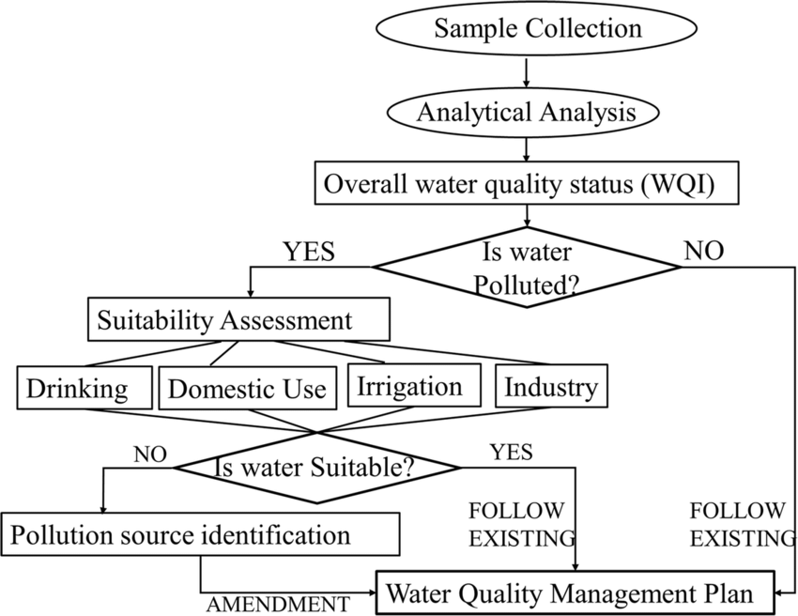

1. Data Collection: Gather data from diverse sources, including water quality reports, environmental sensors, and geographical databases.

2. Data Integration:Combine collected data into a unified format, ensuring compatibility and consistency for meaningful analysis.

3. Data Analysis with Cognos:Utilize IBM Cognos tools to create interactive dashboards and reports, allowing dynamic exploration of water portability metrics.

4. Insight Generation: Analyze patterns and trends within the data to generate actionable insights, identifying areas for improvement and optimization.

5. Decision-Making: Empower stakeholders with the obtained insights, enabling data-driven decisions to enhance water portability strategies and interventions.

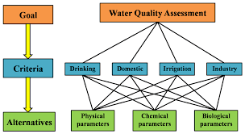

**5.2 Solution & Technical Architecture:**

**Data Ingestion and Integration:**

Raw data from sensors and databases is collected and processed using ETL techniques, integrating it into a cohesive dataset suitable for analysis.

**Cloud-Based Data Storage and Processing:**

Integrated data is stored in scalable cloud storage, enabling efficient real-time or batch processing using platforms like IBM Cloud, Apache Spark or AWS Lambda.

**Data Warehousing and Structured Storage:**

Structured data is stored in a data warehouse, optimizing it for analytical queries, historical analysis, and trend exploration.

**IBM Cognos Analytics for Advanced Analytics and Visualization:**

IBM Cognos Analytics is utilized for advanced analysis, predictive modeling, and creating interactive visualizations and dashboards, enabling meaningful insights.

**Security, Access Control, and Compliance:**

Robust security measures and access controls are implemented to protect data integrity and user privacy, ensuring compliance with regulations such as GDPR and HIPAA. Regular audits and encryption protocols maintain data security standards.

**Solution Architecture Diagram:**

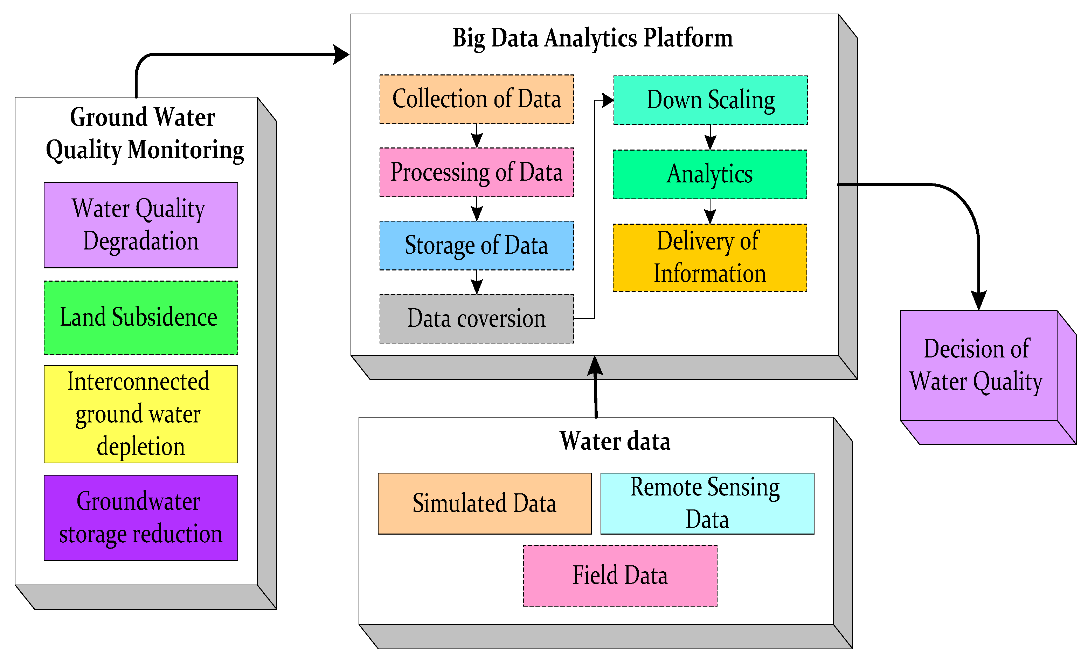

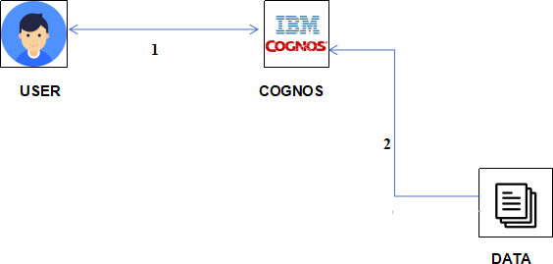

**CHAPTER 6**

**PROJECT PLANNING & SCHEDULING**

**6.1 Technical Architecture:**

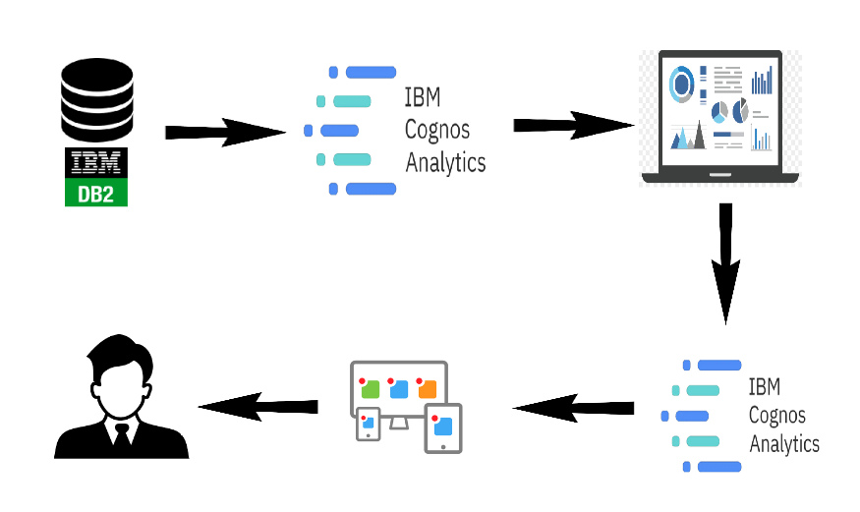

**6.2 Sprint Planning & Estimation:**

|  |  |  |  |  |  |  |
| --- | --- | --- | --- | --- | --- | --- |
| **Sprint** | **Functional**  **Requirement (Epic)** | **User Story**  **Number** | **User Story / Task** | **Story Points** | **Priority** | **Team**  **Members** |
| Sprint-1 | Registration | USN-1 | As a user, I can register for the application by entering my email, password, and confirming my password. | 2 | High | Logesh |
| Sprint-1 |  | USN-2 | As a user, I will receive confirmation email once I have registered for the application | 1 | High | Praveen Kumar |
| Sprint-2 |  | USN-3 | As a user, I can register for the application through Facebook | 2 | Low | Mohammed Shakeel |
| Sprint-1 |  | USN-4 | As a user, I can register for the application through Gmail | 2 | Medium | Logesh |
| Sprint-1 | Login | USN-5 | As a user, I can log into the application by entering email & password | 1 | High | Palaniappan |
|  | Dashboard |  | IBM Cognos Analytics | 1 | High | Palaniappan |

**6.3 Sprint Delivery Schedule:**

|  |  |  |  |  |  |  |
| --- | --- | --- | --- | --- | --- | --- |
| **Sprint** | **Total Story Points** | **Duration** | **Sprint Start Date** | **Sprint End Date (Planned)** | **Story Points**  **Completed (as on**  **Planned End Date)** | **Sprint Release Date (Actual)** |
| Sprint-1 | 20 | 6 Days | 01 Oct 2023 | 03 Oct 2023 | 20 | 16 Oct 2023 |
| Sprint-2 | 20 | 6 Days | 05 Oct 2023 | 07 Oct 2023 |  |  |
| Sprint-3 | 20 | 6 Days | 08 Oct 2023 | 12 Oct 2023 |  |  |
| Sprint-4 | 20 | 6 Days | 12 Oct 2023 | 15 Oct 2023 |  |  |
|  |  |  |  |  |  |  |
|  |  |  |  |  |  |  |
|  |  |  |  |  |  |  |
|  |  |  |  |  |  |  |

**Velocity:**

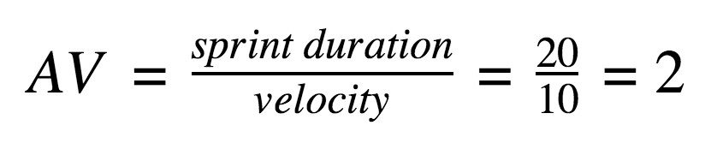

**CHAPTER 7**

**CODING & SOLUTIONING**

**7.1 Feature 1:**

**HTML Code:**

<!DOCTYPE html>

<html lang="en">

<head>

<meta charset="UTF-8">

<meta name="viewport" content="width=device-width, initial-scale=1.0">

<title>Aquatic Insights</title>

<link rel="stylesheet" href="styles.css">

</head>

<body>

<nav>

<ul>

<li><a href="#home">Home</a></li>

<li><a href="#about">About</a></li>

<li><a href="#dashboard">Dashboard</a></li>

<li><a href="#storyboard">Storyboard</a></li>

<li><a href="#team">Team</a></li>

<li class="dropdown">

<a href="javascript:void(0)" class="dropbtn">More</a>

<div class="dropdown-content">

<a href="#contact">Contact</a>

<a href="#get-started">Get Started</a>

</div>

</li>

</ul>

</nav>

<section id="home">

<h1>Welcome to Aquatic Insights!</h1>

<!-- Home Content Goes Here -->

</section>

<section id="about">

<h2>About Us</h2>

<!-- About Content Goes Here -->

</section>

<section id="dashboard">

<h2>Dashboard</h2>

<iframe src="https://us3.ca.analytics.ibm.com/bi/?perspective=dashboard&pathRef=.my_folders%2Fwater%2Bportability%2Bdashboard&action=view&mode=dashboard&subView=model0000018b4735c11d_00000000" width="1200" height="900" width="1200" height="900"></iframe>

</section>

<section id="storyboard">

<h2>Storyboard</h2>

<!-- Storyboard Content Goes Here -->

</section>

<section id="team">

<h2>Our Team</h2>

<!-- Team Members Content Goes Here -->

</section>

<section id="contact">

<h2>Contact Us</h2>

<!-- Contact Form Goes Here -->

</section>

<section id="get-started">

<h2>Get Started</h2>

<!-- Get Started Content Goes Here -->

</section>

</body>

</html>

**CSS code:**

.bg-top {

background-image: url("https://3.imimg.com/data3/LJ/VX/IMFCP-2678881/images-water-250x250.png");

background-size: cover;

height: 100vh;

}

.nav {

background-color: #333;

color: #fff;

padding: 10px 0;

text-align: center;

}

.nav ul {

list-style: none;

padding: 0;

}

.nav ul li {

display: inline;

margin-right: 20px;

}

.nav ul li a {

color: #fff;

text-decoration: none;

}

.dropdown {

display: inline-block;

}

.dropdown-content {

display: none;

position: absolute;

background-color: #f9f9f9;

min-width: 160px;

z-index: 1;

}

.dropdown:hover .dropdown-content {

display: block;

}

**7.2 Feature 2:**

from flask import Flask, render_template

app = Flask(__name__)

@app.route('/')

def home():

return render_template('home.html')

@app.route('/dashboard')

def dashboard():

return render_template('dashboard.html')

if __name__ == '__main__':

app.run(debug=True)

**7.3 Database Schema:**

**Table: Locations**

LocationID (Primary Key): Unique identifier for each monitoring location.

LocationName: Name or description of the monitoring location.

Latitude: Latitude coordinates of the location.

Longitude: Longitude coordinates of the location.

Region: Region or area to which the location belongs.

**Table: Parameters**

ParameterID (Primary Key): Unique identifier for each water quality parameter.

ParameterName: Name of the water quality parameter (e.g., pH, Chlorine, Bacteria Count).

Unit: Measurement unit for the parameter (e.g., ppm, °C).

**Table: Readings**

ReadingID (Primary Key): Unique identifier for each reading recorded.

LocationID (Foreign Key): References LocationID in the Locations table.

ParameterID (Foreign Key): References ParameterID in the Parameters table.

Timestamp: Date and time when the reading was recorded.

Value: Numeric value representing the measurement of the parameter.

Status: Status of the reading (e.g., Normal, Warning, Critical).

**Table: Users**

UserID (Primary Key): Unique identifier for each user.

Username: User's login username.

Password: User's hashed password for authentication.

Role: User's role (e.g., Administrator, Analyst)

**CHAPTER 8**

**PERFORMANCE TESTING**

**8.1 Performace Metrics:**

|  |  |  |
| --- | --- | --- |
| **S.No.** | **Parameter** | **Screenshot** |
| 1.  2.  3.  4.  5.  6. | Dashboard design  Data Responsiveness  Amount Data to Rendered (DB2 Metrics)  Utilization of Data Filters  Effective User Story  Descriptive Reports | 5  Cognos Analytics of Potability |

**CHAPTER 9**

**RESULTS**

**9.1 Output Screenshots:**

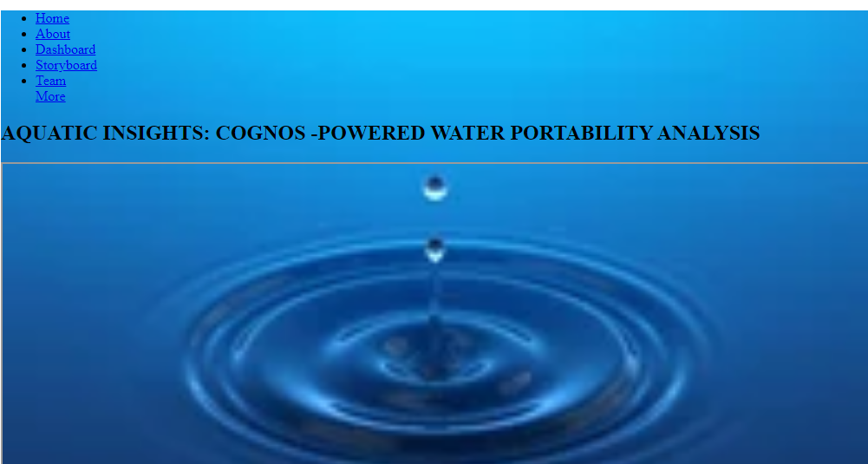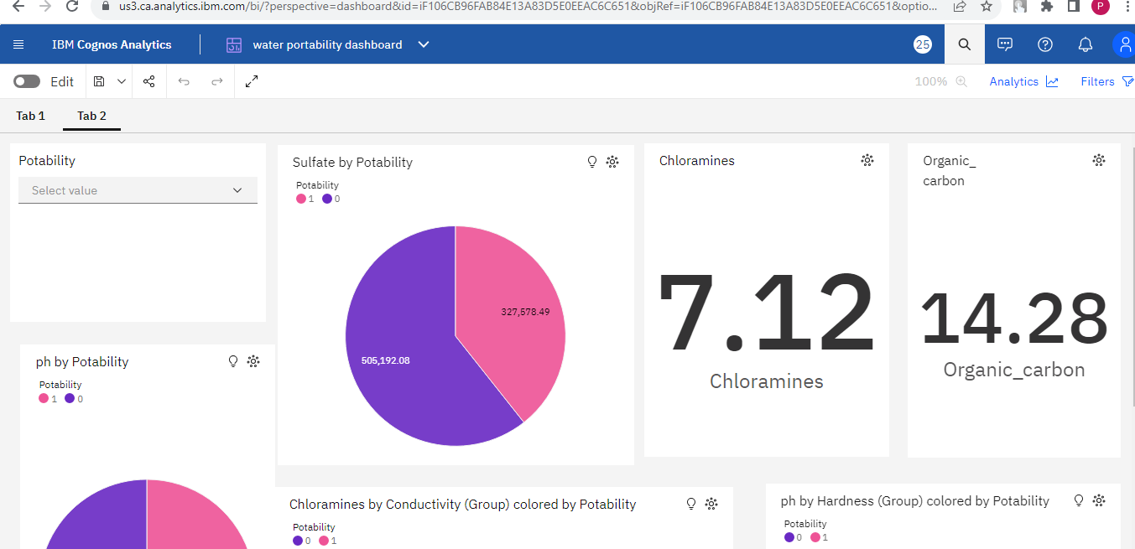

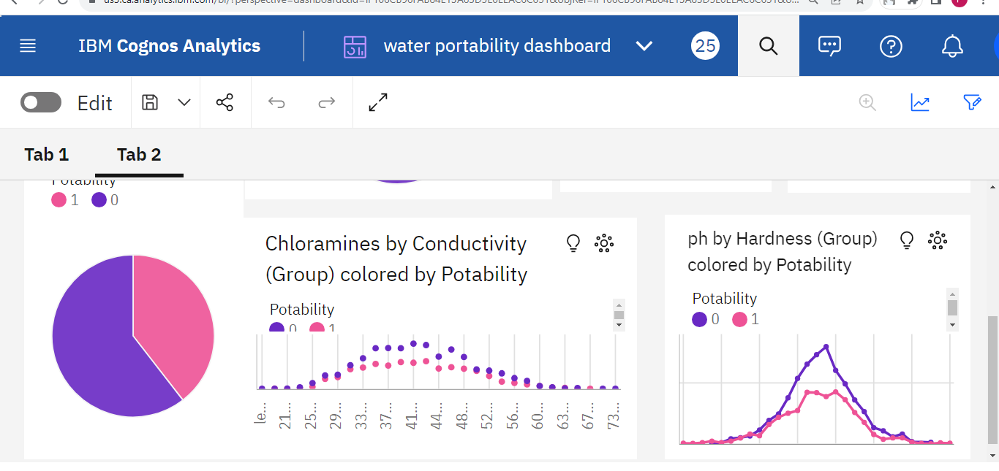

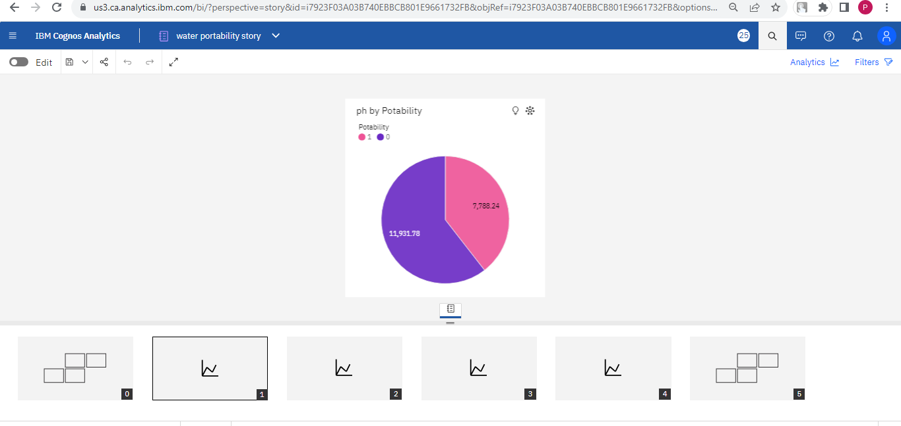

**CHAPTER 10**

**ADVANTAGES & DISADVANTAGES**

**Advantages of the solution:**

**Data-Driven Decision Making:**

Enables evidence-based decision-making by providing real-time insights into water quality, facilitating proactive measures to ensure portable water availability.

**Enhanced Public Health:**

Helps identify water quality issues promptly, allowing authorities to take corrective actions swiftly, thus safeguarding public health.

**Environmental Conservation:**

Facilitates the monitoring of environmental parameters, aiding in the conservation of aquatic ecosystems and biodiversity.

**Efficient Resource Allocation:**

Optimizes resource allocation by identifying areas with the greatest need for interventions, ensuring efficient use of funding and resources.

**Stakeholder Empowerment:**

Empowers various stakeholders, including governmental bodies, environmental agencies, and local communities, with valuable insights for informed participation in water management initiatives.

**Disadvantages:**

**Data Accuracy and Reliability:**

Relies heavily on the accuracy and reliability of input data; erroneous or outdated data could lead to misleading analysis and decisions.

**Data Security Concerns:**

Handling sensitive water quality data requires robust security measures to prevent unauthorized access and ensure compliance with data protection regulations.

**Technological Barriers:**

Requires advanced technological infrastructure and skilled personnel for implementation, which might be a challenge in regions with limited resources and expertise.

**Maintenance and Updates:**

Requires continuous maintenance, updates, and monitoring to ensure the system remains effective and aligns with evolving water quality standards and technologies.

**User Adoption and Training:**

Users, especially in less tech-savvy communities or organizations, may require extensive training to effectively use the system, impacting its overall adoption and usability.

**Cost Implications:**

Implementation and maintenance costs, including technology infrastructure, software licenses, and personnel training, could be substantial, potentially posing a financial burden on smaller organizations or communities.

**Interoperability Challenges:**

Integration with existing water management systems and databases might pose challenges due to interoperability issues, requiring seamless data exchange protocols and standards.

**CHAPTER 11**

**CONCLUSION**

In conclusion, "Aquatic Insights: Cognos-Powered Water Portability Analysis" presents a powerful solution for addressing critical challenges in water quality management. By leveraging advanced technologies and data analytics, this system empowers decision-makers, environmental agencies, and communities to make informed choices and take proactive measures to ensure the availability of portable water sources and promote environmental sustainability.

The advantages of this solution are significant: it enables data-driven decision-making, enhances public health by identifying water quality issues promptly, contributes to environmental conservation efforts, optimizes resource allocation, and empowers various stakeholders. These benefits signify a positive step toward achieving sustainable water management practices and fostering healthier communities and ecosystems.

However, it's crucial to acknowledge the challenges and limitations. Issues related to data accuracy, security, technological barriers, maintenance, user adoption, cost implications, and interoperability need careful consideration and strategic planning. Overcoming these challenges requires collaborative efforts, continuous monitoring, and adaptability to emerging technologies and standards.

In moving forward, a holistic approach that integrates technology, policy-making, community engagement, and ongoing education is essential. By addressing the limitations thoughtfully and capitalizing on the strengths of the solution, "Aquatic Insights: Cognos-Powered Water Portability Analysis" has the potential to be a transformative tool in the realm of water quality management, leading to sustainable practices, improved public health, and the preservation of our precious aquatic ecosystems.

**CHAPTER 12**

**FUTURE SCOPE**

Advanced Sensor Technologies: Explore cutting-edge sensor technologies for more accurate and diverse data collection, ensuring a comprehensive understanding of water quality parameters.

Predictive Analytics: Implement predictive analytics and machine learning algorithms to anticipate water quality fluctuations, enabling proactive measures and timely interventions.

Smart Infrastructure: Develop smart water infrastructure equipped with IoT devices, enabling real-time monitoring and automation of water quality control processes.

Citizen Science Initiatives: Foster citizen science initiatives through mobile apps and community engagement, enhancing data collection and public awareness of water quality issues.

Blockchain for Data Security: Utilize blockchain technology for secure, immutable storage of water quality data, ensuring data integrity and building trust in the information.

Spatial Analysis: Integrate Geographic Information Systems (GIS) for spatial analysis, facilitating location-based insights and targeted pollution mitigation strategies.

Cross-Sector Collaboration: Encourage collaboration between government bodies, research institutions, technology companies, and local communities for comprehensive water quality management solutions.

Environmental Impact Assessments: Conduct detailed environmental impact assessments using advanced modeling techniques to gauge the ecological effects of various activities and propose sustainable practices.

Real-time Decision Support: Develop intuitive dashboards and decision support systems for stakeholders, enabling real-time analysis, visualization, and informed decision-making.

Policy Advocacy and Standardization: Advocate for evidence-based policy changes and universal data exchange standards, influencing regulations and fostering interoperability among water quality databases and systems.

**CHAPTER 13**

**APPENDIX**

**Source Code:**

<!DOCTYPE html>

<html lang="en">

<head>

<meta charset="UTF-8">

<meta name="viewport" content="width=device-width, initial-scale=1.0">

<title>Aquatic Insights</title>

<link rel="stylesheet" href="styles.css">

</head>

<body>

<nav>

<ul>

<li><a href="#home">Home</a></li>

<li><a href="#about">About</a></li>

<li><a href="#dashboard">Dashboard</a></li>

<li><a href="#storyboard">Storyboard</a></li>

<li><a href="#team">Team</a></li>

<li class="dropdown">

<a href="javascript:void(0)" class="dropbtn">More</a>

<div class="dropdown-content">

<a href="#contact">Contact</a>

<a href="#get-started">Get Started</a>

</div>

</li>

</ul>

</nav>

<section id="home">

<h1>Welcome to Aquatic Insights!</h1>

<!-- Home Content Goes Here -->

</section>

<section id="about">

<h2>About Us</h2>

<!-- About Content Goes Here -->

</section>

<section id="dashboard">

<h2>Dashboard</h2>

<iframe src="https://us3.ca.analytics.ibm.com/bi/?perspective=dashboard&pathRef=.my_folders%2Fwater%2Bportability%2Bdashboard&action=view&mode=dashboard&subView=model0000018b4735c11d_00000000" width="1200" height="900" width="1200" height="900"></iframe>

</section>

<section id="storyboard">

<h2>Storyboard</h2>

<!-- Storyboard Content Goes Here -->

</section>

<section id="team">

<h2>Our Team</h2>

<!-- Team Members Content Goes Here -->

</section>

<section id="contact">

<h2>Contact Us</h2>

<!-- Contact Form Goes Here -->

</section>

<section id="get-started">

<h2>Get Started</h2>

<!-- Get Started Content Goes Here -->

</section>

</body>

</html>

**CSS code:**

.bg-top {

background-image: url("https://3.imimg.com/data3/LJ/VX/IMFCP-2678881/images-water-250x250.png");

background-size: cover;

height: 100vh;

}

.nav {

background-color: #333;

color: #fff;

padding: 10px 0;

text-align: center;

}

.nav ul {

list-style: none;

padding: 0;

}

.nav ul li {

display: inline;

margin-right: 20px;

}

.nav ul li a {

color: #fff;

text-decoration: none;

}

.dropdown {

display: inline-block;

}

.dropdown-content {

display: none;

position: absolute;

background-color: #f9f9f9;

min-width: 160px;

z-index: 1;

}

.dropdown:hover .dropdown-content {

display: block;

}

**Flask Application:**

from flask import Flask, render_template

app = Flask(__name__)

@app.route('/')

def home():

return render_template('home.html')

@app.route('/dashboard')

def dashboard():

return render_template('dashboard.html')

if __name__ == '__main__':

app.run(debug=True)

**GitHub & Project Demo Link:**

**Github:**

[**https://github.com/PALANIAPPAN-PL/naanmudhalvan-Data-Analytics**](https://github.com/PALANIAPPAN-PL/naanmudhalvan-Data-Analytics)

**Project Demo Link:**

**https://gemoo.com/tools/upload-video/share/575395858307117056?codeId=vz8okAJXebLrr&card=575395853227814912&origin=videolinkgenerator**